

ATAR Physics
Year 12 2019

Task 6:
Particles, Waves and Quanta Research Assignment

Student Name: ______________________

I acknowledge that all the information contained in this task is my own work and not taken from other sources. If other sources have been used they have been acknowledged in my references.

____________________________________
(Student Signature)

Teacher Comments:

Particles, Waves and Quanta

- Replace the following statements with a single word. (5 marks)

- Maximum displacement a particle moves from its mean position ___________________
- Area of sound wave where particles move together. ___________________
- Type of wave where particle displacement is perpendicular to the
direction of energy. ___________________
- Distance between two successive points on distance/displacement
graph. ___________________
e. Distance between two successive points on distance/time graph. ___________________
f. Combination of two waves that meet and form composite wave. ___________________
g. Part of standing wave where displacement of particles is zero. ___________________
h. Multiples of a fundamental frequency. ___________________
i. Waxing and waning of sound caused by sounds of similar frequencies. ________________
- Frequency of driving force coincides with natural frequency of body
being force to vibrate increasing vibrations. ___________________
- Determine the amplitude and wavelength in the following wave.
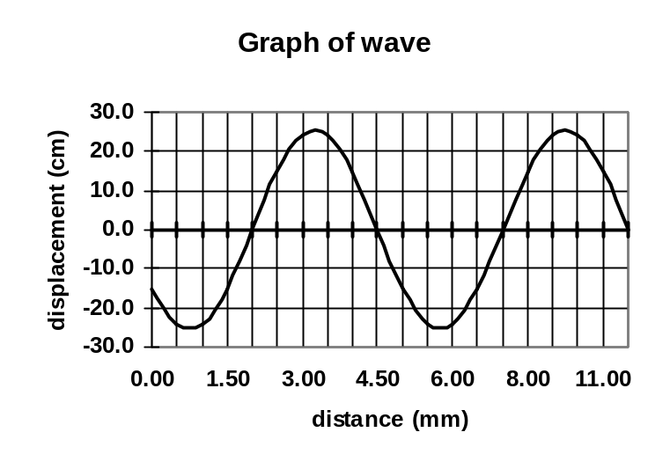

Wavelength: _______________

Amplitude: _______________

- While watching waves, a walker sees the waves arriving on the beach every 2.00 seconds and the distance between crests to be 10.0 m. What is the speed of the wave? (2 marks)

- List three differences between sound waves and light waves. (3 marks)
- ________________________________________________________________________
- ________________________________________________________________________
- ________________________________________________________________________

- Complete the following wave diagrams then underneath the diagram write the name of the wave behaviour that is occurring.

Waves passing through an opening  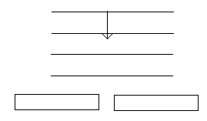 | Person above aquarium listening to noisy fish.  air  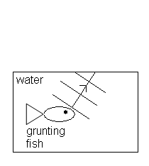 | Waves reflected on a circular wall.  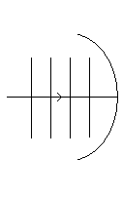

- Draw the resultant wave over the top of this diagram of two waves. (2 mark)

Displacement (m)
0.3
0.2
0.1
0
-0.1 1 2 3 4 5 6 7 8 9 10 11 Distance (m)
-0.2
-0.3

- An organ pipe, open at both ends, produces the middle C note (256 Hz) when sustaining a standing wave at its third harmonic.
- Draw a diagram to represent the standing wave in the pipe in its third harmonic, labelling the nodes and antinodes. (2 mark)

- Calculate the fundamental frequency of the organ pipe. (2 mark)

- A student sets up an experiment using a large pipe in a tall cylinder of water. She sounds a 640 Hz tuning fork over the top of the tube and slowly raises the tube until the resonance of the fundamental frequency is heard. (Speed of sound in air is 342 ms⁻¹).

- What is resonance? ________________________________________________________
________________________________________________________________________
________________________________________________________________________
________________________________________________________________________
________________________________________________________________________
________________________________________________________________________
________________________________________________________________________
________________________________________________________________________
- What length of pipe will be above the water? (2 marks)

- If the pipe is 70.0 cm long, how many harmonics would be heard? (2 marks)

- Two violins strings of the same note are played, but a loud – soft sound is heard.
What is the name given to this phenomena and why does it occur? (2 mark) _____________________________________________________________________________________________________________________________________________________________________________________________________________________________________________________________________________________________________________________________________________________________________________________________________________________________________________________________________________________________________________________________________________
- A guitar string plucked so that it produces it fundamental frequency of 216 Hz. If the speed of sound on that day was 346 ms⁻¹, what was the length of the string? (2 marks)

- A bass trombone (T) which has a low frequency range and a piccolo (P) which has a high frequency range are being played in a room which has the door open. You were standing at X (in the diagram below).
X

room viewed from P
above T

- Which of the instruments would you hear better if they were playing with the same loudness? _____________________________ (1 mark)
- Name the physical phenomenon which led you to choose either the trombone or the piccolo and explain why you chose your answer.

Name: __________________________________ (1 mark)
Explanation: ______________________________________________________________
________________________________________________________________________
________________________________________________________________________
________________________________________________________________________
________________________________________________________________________
_________________________________________________________________ (2 mark)
- Two loud speakers of the same frequency are set up facing each other to produce a standing wave. The speakers are 2.0 m apart and have a frequency of 680 Hz. The speed of sound is 340 ms⁻¹.
- As you move from speaker to speaker, you hear loud and soft sounds. Explain why.
________________________________________________________________________
________________________________________________________________________
________________________________________________________________________
________________________________________________________________________
________________________________________________________________ (2 marks)
- What is the wavelength of this sound? (2 mark)

- Assuming an anti-node has been created at each speaker, how many times will the sound go soft as you move from speaker to speaker. (2 marks)

- You know that electromagnetic radiation exhibits a “dual nature”. With examples, explain
what is meant by a “dual nature”? (2 marks)
_____________________________________________________________________________
_____________________________________________________________________________
_____________________________________________________________________________
_____________________________________________________________________________
_____________________________________________________________________________
_____________________________________________________________________________
_____________________________________________________________________________
_____________________________________________________________________________
_____________________________________________________________________________

- A neon sign emits photons of wavelength 7.10 x 10⁻⁷ m.
- To which region of the electromagnetic spectrum do these photons belong? (1 mark)
________________________________________________________________________
- What is the energy of the photons in electron volts. (3 marks)

- An advertisement for a new laundry detergent boasts:
“DAZZLE laundry detergent makes your clothes WHITER than WHITE.”
Describe how laundry detergent manufacturers can cause clothes to appear to produce white light. (3 marks)
_____________________________________________________________________________
_____________________________________________________________________________
_____________________________________________________________________________
_____________________________________________________________________________
_____________________________________________________________________________
_____________________________________________________________________________

- Look at the two spectrums below. Name the type of spectrum produced in each case, A and B, then explain the formation of each including an example. (6 marks)
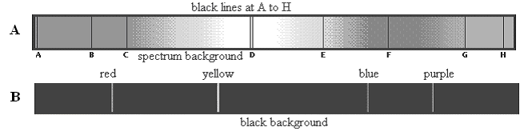

_____________________________________________________________________________
_____________________________________________________________________________
_____________________________________________________________________________
_____________________________________________________________________________
_____________________________________________________________________________
_____________________________________________________________________________

Explain the difference between a photon and a quantum. (2 marks)
_____________________________________________________________________________
____________________________________________________________________________
_____________________________________________________________________________
_____________________________________________________________________________

- When looking at the sun through a spectroscope, a spectrum can be seen which has thin black lines on it.
  - What is the name given to this type of spectrum? __________________________(1mark)
  - What is the name given to these black lines (in your text so look it up)?
__________________________________________________________________(1mark)
  - Why do they occur?
_________________________________________________________________________
_________________________________________________________________________
_________________________________________________________________________
_________________________________________________________________________
_________________________________________________________________________
_________________________________________________________________________
(2 marks)

- a. Look at the energy level diagram for an atom. How many possible transitions are there for this
atom (write the number in the space provided below), draw them. (2 marks)

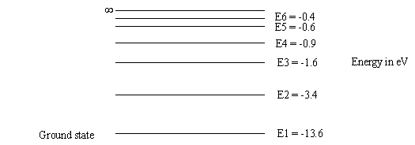

Number of transitions = ________________________ (2 marks)

- In the energy transition diagram above, what would happen if an electron were given 14.8 eV?

What name do we give to this? (2 marks)

__________________________________________________________________________
__________________________________________________________________________
__________________________________________________________________________
__________________________________________________________________________
- An electron in the diagram above is given enough energy to jump to the third level. It then returns to ground state via the second level where it emits light. What colour is the light?
(4 marks)

- A microwave has a frequency of 3.40 x 10¹⁰ Hz. If the microwave has a power output of 900 W, how many photons per second are transmitted? (2 marks)

- Strong nuclear forces hold protons and neutrons together. Protons and neutrons are hadrons and each hadron is made up of three quarks. There are six types of quarks each of which has a fractional charge. Up-type quarks have a charge of +2/3 electric charge, while down-type quarks have -1/3 electric charge. If an electric charge is the charge on an electron, determine the quarks that make up a neutron and a proton. You must show your working to justify your answer.

- a neutron (2 marks)

- a proton (2 marks)

- While astronomers still use light telescopes to view the universe, much more information is available by using other waves within the electromagnetic spectrum such as radio-waves, infra-red waves, ultra-violet waves and X-rays. Select ONE of these and explain what information is available that is not visible using a light telescope. (3 marks)

____________________________________________________________________________________________________________________________________________________________________________________________________________________________________________________________________________________________________________________________________________________________________________________________________________________________________________________________________________________________________________________________________________________________________________________________________________________________________________________________________________________________________________________________________________________________________________________________________________
- Label the following diagram showing the production of X-rays. (3 marks)
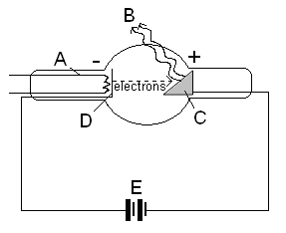

A: _______________________________________

B: _______________________________________

C: _______________________________________

D: _______________________________________

E: _______________________________________

- Describe and explain the following fundamental cosmological concepts.
- How red-shift is evidence of the Big Bang Theory. (3 marks)
____________________________________________________________________________________________________________________________________________________________________________________________________________________________________________________________________________________________________________________________________________________________________________________________________________________________________________________________________________________________________________________________________________________________________________________________________________________________________________________________________________________________________________________________________________________________________________________________________________________________________________________________________________________________________________________________________________________________________________________________________________________________________________________________________________

- The two proposed models for the behaviour of the universe. (2 marks)
__________________________________________________________________________________________________________________________________________________________________________________________________________________________________________________________________________________________________________________________________________________________________________________________________________________________________________________________________________________________________________________________________________________________________________________________________________________________________________________________________________________________________________________________________________________________________________________________________________________________________________________________________________________________________________________________________________________________________________________________________
- Hubble’s law, red-shift and the expanding universe. (2 marks)

__________________________________________________________________________________________________________________________________________________________________________________________________________________________________________________________________________________________________________________________________________________________________________________________________________________________________________________________________________________________________________________________________________________________________________________________________________________________________________________________________________________________________________________________________________________________________________________________________________________________________________________

